

Compiler Construction Lab 9

Name: Kashaf Ahmad
Sap ID: 53155
Submitted To: Ma`am Hasnat Bibi

Task 1:

Given Grammar
S → A B
A → a A | b
B → c B | d

Step 1: Augmented Grammar
S' → S
S → A B
A → a A
A → b
B → c B
B → d

Step 2: LR(0) Item Sets

I0 (Closure of S' → .S)
S' → .S
S → .A B
A → .a A
A → .b

I1 = GOTO(I0, S)
S' → S.

I2 = GOTO(I0, A)
S → A .B
B → .c B
B → .d

I3 = GOTO(I0, a)
A → a .A
A → .a A
A → .b

I4 = GOTO(I0, b)
A → b.

I5 = GOTO(I2, B)
S → A B.

I6 = GOTO(I2, c)
B → c .B
B → .c B
B → .d

I7 = GOTO(I2, d)
B → d.

I8 = GOTO(I3, A)
A → a A.

Step 3: Action & Goto Table
State | a | b | c | d | $ | S | A | B
0 | s3 | s4 |  |  |  | 1 | 2
1 |  |  |  |  | acc
2 |  |  | s6 | s7 |  |  |  | 5
3 | s3 | s4 |  |  |  |  | 8
4 | r(A→b) | r(A→b) | r(A→b) | r(A→b) | r(A→b)
5 |  |  |  |  | r(S→AB)
6 |  |  | s6 | s7 |  |  |  | 9
7 | r(B→d) | r(B→d) | r(B→d) | r(B→d) | r(B→d)
8 | r(A→aA) | r(A→aA) | r(A→aA) | r(A→aA) | r(A→aA)
9 | r(B→cB) | r(B→cB) | r(B→cB) | r(B→cB) | r(B→cB)

Step 4: Explanation
- Shift (sX): push symbol and go to state X
- Reduce (rY): apply production
- Accept: successful parsing
Example:
- r(A→b) → replace b with A
- r(S→AB) → final reduction
Code:
#include <iostream>
#include <stack>
#include <map>
#include <vector>
using namespace std;
int main() {
// Action Table
map<int, map<string, string>> action;
action[0]["a"] = "s3";
action[0]["b"] = "s4";
action[1]["$"] = "acc";
action[2]["c"] = "s6";
action[2]["d"] = "s7";
action[3]["a"] = "s3";
action[3]["b"] = "s4";
action[4]["c"] = "r3";
action[4]["d"] = "r3";
action[5]["$"] = "r1";
action[6]["c"] = "s6";
action[6]["d"] = "s7";
action[7]["$"] = "r5";

action[8]["c"] = "r2";
action[8]["d"] = "r2";
action[9]["$"] = "r4";
// Goto Table
map<int, map<string, int>> goTo;
goTo[0]["S"] = 1;
goTo[0]["A"] = 2;
goTo[2]["B"] = 5;
goTo[3]["A"] = 8;
goTo[6]["B"] = 9;
// Productions length
map<int, int> prodLen;
prodLen[1] = 2; // S ? A B
prodLen[2] = 2; // A ? a A
prodLen[3] = 1; // A ? b
prodLen[4] = 2; // B ? c B
prodLen[5] = 1; // B ? d
stack<int> st;
st.push(0);
vector<string> input;
string x;
cout << "Enter input (end with $): ";
while (cin >> x) {
input.push_back(x);
if (x == "$") break;
}
int i = 0;
while (true) {
int state = st.top();
string curr = input[i];
string act = action[state][curr];
if (act == "") {
cout << "Error\n";
break;
}
if (act[0] == 's') {
int next = stoi(act.substr(1));
st.push(next);
cout << "Shift " << curr << endl;
i++;
}
else if (act[0] == 'r') {
int p = stoi(act.substr(1));

int len = prodLen[p];
for (int j = 0; j < len; j++) st.pop();

int top = st.top();

string lhs;
if (p == 1) lhs = "S";
else if (p == 2 || p == 3) lhs = "A";
else lhs = "B";
st.push(goTo[top][lhs]);
cout << "Reduce using production " << p << endl;
}
else if (act == "acc") {
cout << "Accepted\n";
break;
}
}
return 0;
}
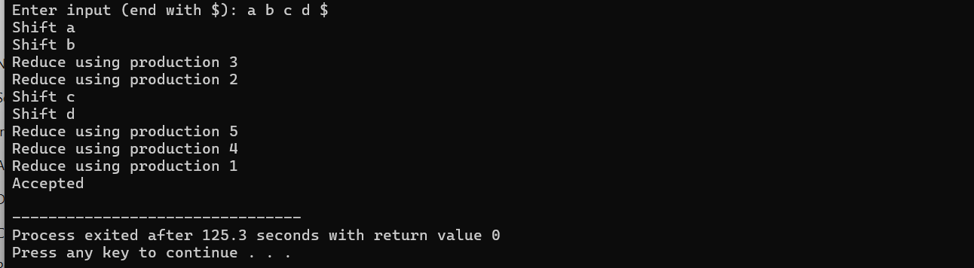
Task 2:
Grammar for SLR:
S → A B
A → a A | b
B → c B | d

Step 1: FOLLOW Sets
FOLLOW(S) = { $ }
FOLLOW(A) = { c, d }
FOLLOW(B) = { $ }

Step 2: SLR Table (Key Idea)
- Reduce only when lookahead ∈ FOLLOW(LHS)

Step 3: SLR Action Table (Simplified)
State | a | b | c | d | $
0 | s3 | s4
1 |  |  |  |  | acc
2 |  |  | s6 | s7
3 | s3 | s4
4 |  |  | r(A→b) | r(A→b)
5 |  |  |  |  | r(S→AB)
7 |  |  |  |  | r(B→d)
8 |  |  | r(A→aA) | r(A→aA)
9 |  |  |  |  | r(B→cB)

Code:
#include <iostream>
#include <stack>
#include <vector>
#include <map>
using namespace std;

int main(){

// ====== Action Table ======
map<int,map<string,string>> action;

action[0]["a"]="s3";
action[0]["b"]="s4";

action[1]["$"]="acc";

action[2]["c"]="s6";
action[2]["d"]="s7";

action[3]["a"]="s3";
action[3]["b"]="s4";

action[4]["c"]="r3";
action[4]["d"]="r3";

action[5]["$"]="r1";

action[6]["c"]="s6";
action[6]["d"]="s7";

action[7]["$"]="r5";

action[8]["c"]="r2";
action[8]["d"]="r2";

action[9]["$"]="r4";

// ====== Goto Table ======
map<int,map<string,int>> goTo;

goTo[0]["S"]=1;
goTo[0]["A"]=2;
goTo[2]["B"]=5;
goTo[3]["A"]=8;
goTo[6]["B"]=9;

// ====== Production lengths ======
map<int,int> prodLen;

prodLen[1]=2; // S ? A B
prodLen[2]=2; // A ? a A
prodLen[3]=1; // A ? b
prodLen[4]=2; // B ? c B
prodLen[5]=1; // B ? d

// ====== Input ======
vector<string> input;
string sym;

cout << "Enter input (space separated, end with $): ";
while(cin >> sym){
input.push_back(sym);
if(sym=="$") break;
}

// ====== Stack ======
stack<int> st;
st.push(0);

int i=0;

cout << "\n=== Parsing Steps ===\n";

while(true){
int state = st.top();
string curr = input[i];

string act = action[state][curr];

if(act==""){
cout<<"Error\n";
break;
}

if(act[0]=='s'){ // Shift
int next = stoi(act.substr(1));
st.push(next);
cout<<"Shift '"<<curr<<"', push state "<<next<<endl;
i++;
}
else if(act[0]=='r'){ // Reduce
int p = stoi(act.substr(1));

int len = prodLen[p];
for(int j=0;j<len;j++) st.pop();

int top = st.top();

string lhs;
if(p==1) lhs="S";
else if(p==2 || p==3) lhs="A";
else lhs="B";

st.push(goTo[top][lhs]);

cout<<"Reduce by production "<<p
<<", push state "<<st.top()<<endl;
}
else if(act=="acc"){
cout<<"Input Accepted\n";
break;
}
}

return 0;
}
